Is not it nice to have a device that lights your room to turn on and turn off the lights in your room when you go out or enter the room?



** Problem Statement**

For my final project, I will use the PIR Sensor to detect any movement occurring in a 20-foot orbit, which can monitor movement from 20 feet. I will also use the Relay to connect room lamps, for example, in order for Relay to control the power of the lights. And of course the Arduino, which is the heart of the project, I will program it to accomplish its mission successfully. Maybe I will be able also to improve it to do a security device against theft, or a device that runs your favourite music while in the room.

 Materials

 Breadboard

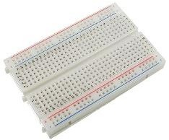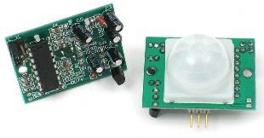

Pir sensor



Relay

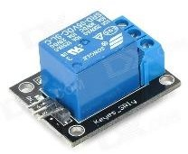

 Arduino

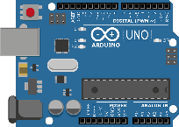

 Jumper Wires





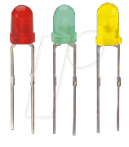

LED



Computer



* The first step :



Connect the 5volt port on the Arduino to the power outlets on the side of the breadboard and the

Gnd port on the Arduino on the negative power outlets on the breadboard as

Shown in the image.

 The second step:

Connect the positive power cord of the sensor to the 5 v port on the breadboard, and the negative power cord to the

Gnd port on the breadboard.

Plug the Signal cable into port 9 on the card.

 The third step:

Connect the reel power cord to the 5 v port on the breadboard, and the negative power cord to the Gnd port on the breadboard.

Connect the signal cable to port 10 on the card.

* The fourth step:



Connect the LED's long (+) leg to port 13 and the leg (-) to the Gnd port next to port 13.



 The programming text is written as follows:

When the motion sensor detects any movement in its surroundings it activates the LED and the relay to connect the power source to the braille-ready supply. After one and a half minutes (90000 mili sec), the power is separated from the relay plug and the LED is turned off. Arduino deals with time in milliseconds, every second is 1000 milliseconds.